



Product Name: AMBO! Web

Device Type: Public phone

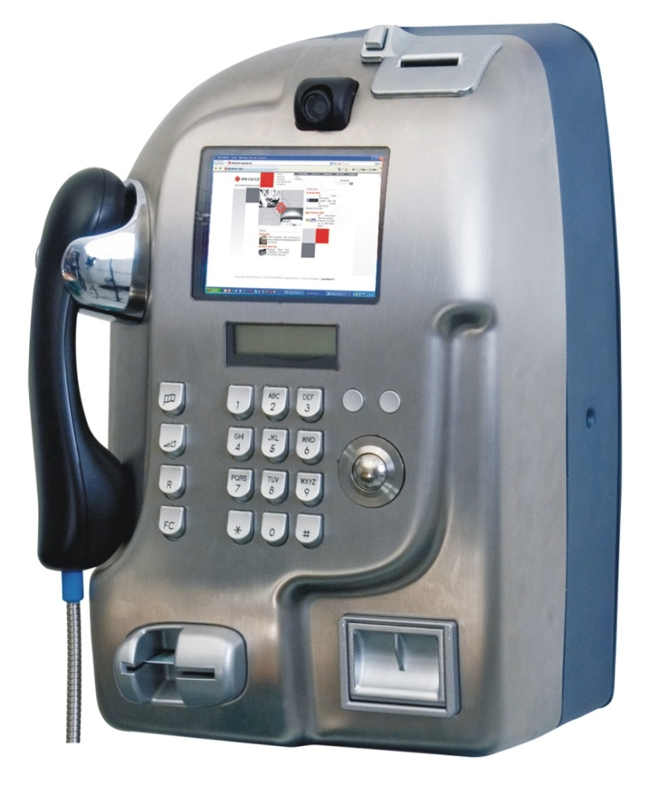Manufacturer: IPM Group

OS Version: Windows XP Embedded

Processor: Geode GX-MMX 500Mhz

RAM: 512Mb

System Integrator: BEPS Engineering S.r.l.

Avalaibility: 2007

Key technologies: Embedded + EWF + Custom-Shell

Message box default reply

[**www.ipmgroup.eu**](http://www.ipmgroup.eu)

Talking point: Reliability -





Product Name: SkyEFIS

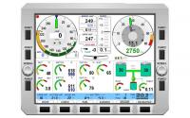Device Type: Electronic Flight Information System

Manufacturer: DigiSky

OS Version: Windows Embedded Standard 2009

Processor: Intel x86

RAM: 512Mb

System Integrator: BEPS Engineering S.r.l.

Avalaibility: 2007

[**www.digisky.it**](http://www.digisky.it)

Key technologies: Embedded + EWF + Custom-Shell

Message box default reply

Talking point: Reliability -



Product Name: EASYROAD 3G

Device Type: Personal Navigator Device

Manufacturer: Magneti Marelli

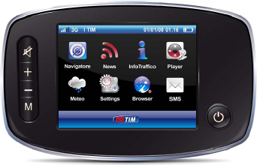OS Version: Windows Embedded CE 5.0

Processor: STMicroelctronics Nomadic

RAM: 64Mb

System Integrator: BEPS Engineering S.r.l.

Avalaibility: 2009

Key technologies: CF.NET 2.0 + Gesture + custom Shell

Connection manager

[**www.magnetimarelli.**](http://www.magnetimarelli.)

Talking point: Connection -

Development with CF .NET



Product Name: OPEN-LIGHT

Device Type: Access Control System

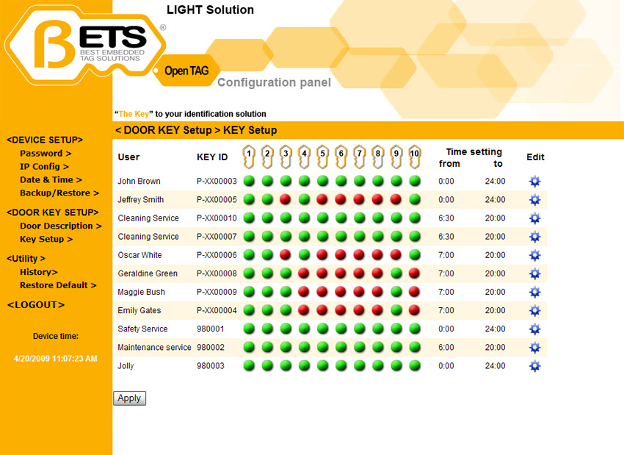Manufacturer: BETS Solutions

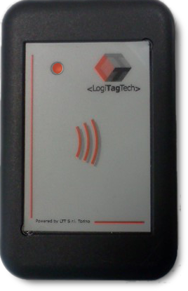OS Version: Windows Embedded CE 6.0

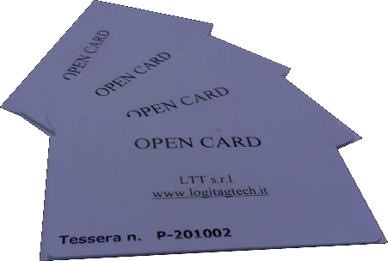Processor: MSTI PSX-300 366MHz

RAM: 128Mb

System Integrator: BEPS Engineering S.r.l.

Avalaibility: 2007

[**www.betsolution.it**](http://www.betsolution.it)

Key technologies: Headless Embedded + WebServer

Talking point: Reliability – WatchDog – Date&Time



Product Name: Guitar Switch

Device Type: Enhanced Guitar Switch

Manufacturer: BEPS (Prototype)

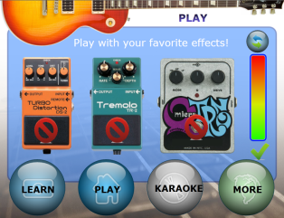OS Version: Windows Embedded CE 6.0 R3

Processor: Vortex X86 800Mhz

RAM: 256Mb

System Integrator: BEPS Engineering S.r.l.

Avalaibility: TBD

Key technologies: Embedded + Gesture +

Silverlight for Embedded

Talking point: Easy to use /music recorder /

Karaoke

[**www.bepseng.it**](http://www.bepseng.it)





Product Name: PHOME

Device Type: Home phone (for old/disabled)

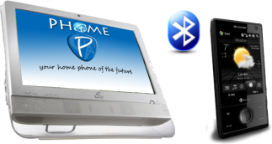Manufacturer: BEPS (Prototype)

OS Version: Windows Embedded Standard 7

Processor: Intel Atom n270

RAM: 1Gb

System Integrator: BEPS Engineering S.r.l.

Avalaibility: TBD

Key technologies: Embedded + Text to speach +

Custom-Shell + Voice Recognition

[**www.bepseng.it**](http://www.bepseng.it)

Talking point: Easy to use / No maintenance / WiFi





Product Name: AVALON

logo-ismb alta definizione.tif

Device Type: Medical device

Manufacturer: MIC (Prototype)

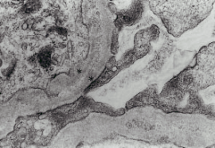OS Version: Windows Embedded Standard 7

C:\Beps-22\Marketing\Debug\Images\gridchart.pngProcessor: Core-i5-450M 2.4GHz

RAM: 4Gb

System Integrator: BEPS Engineering S.r.l.

Avalaibility: TBD

Key technologies: Multitouch + Gesture + custom Shell

Talking point: Screen dimension -

[**www.mictorino.it**](http://www.mictorino.it)



Product Name: GraCe

Device Type: Graphycal Enhanced Control

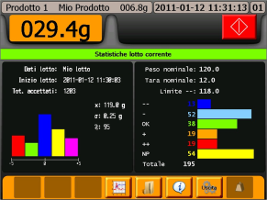Manufacturer: BEPS (Prototype)

OS Version: Windows Embedded CE 6.0 R3

Processor: Vortex X86 800Mhz

RAM: 256Mb

System Integrator: BEPS Engineering S.r.l.

Avalaibility: 2Q-2011

Key technologies: .NET Compact Framework +

rich graphycal controls

[**www.bepseng.it**](http://www.bepseng.it)

Talking point: Integration and editing in Visual Studi